Contents

CRUD Insert 2

CRUD Read 9

CRUD Update 15

CRUD Delete 22

# CRUD Insert

INSERT INTO nextofkin

(NOK_ID, NOK_Name, NOK_Relation, NOK_Address_Street, NOK_Address_City, NOK_Address_PCode, NOK_Phone, NOK_Student_ID)

VALUES

(234567, ‘John Smith’, ‘Father’, ’41 Road Street’, ‘Bolton’, ‘BL3 1HP’, ‘01204 472222’, 1234567);

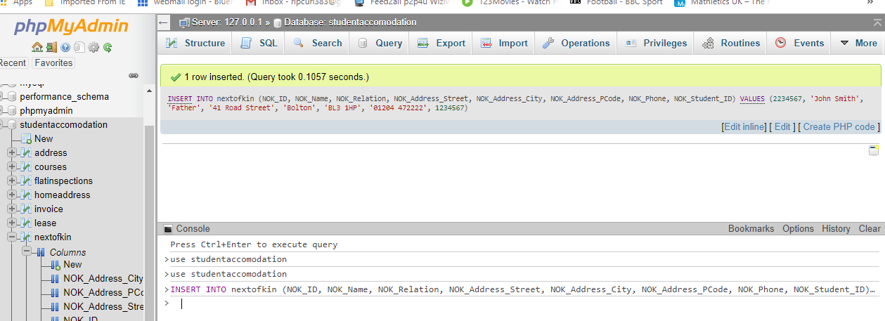

INSERT INTO courses

(Course_ID, Course_Title, Course_Year, Course_Leader, Course_Phone, Course_Room, Course_Dept)

VALUES

(2345678, ‘BSC Computing’, ‘3’, ‘Mr Walton’, ‘01204 435656’, ‘D104’, ‘Computing’);

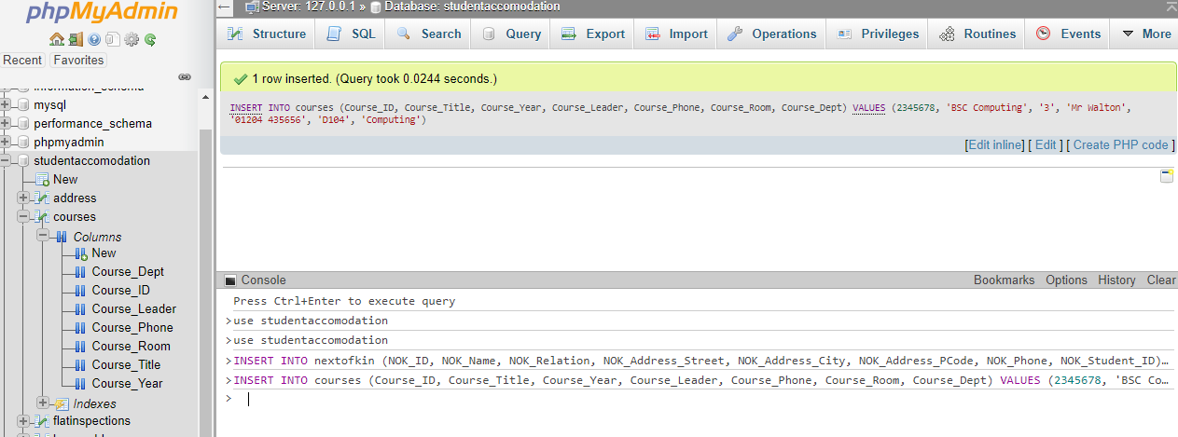

INSERT INTO paymentmethods

(Payment_Code, Payment_Description)

VALUES

(1234, 'Credit Card');

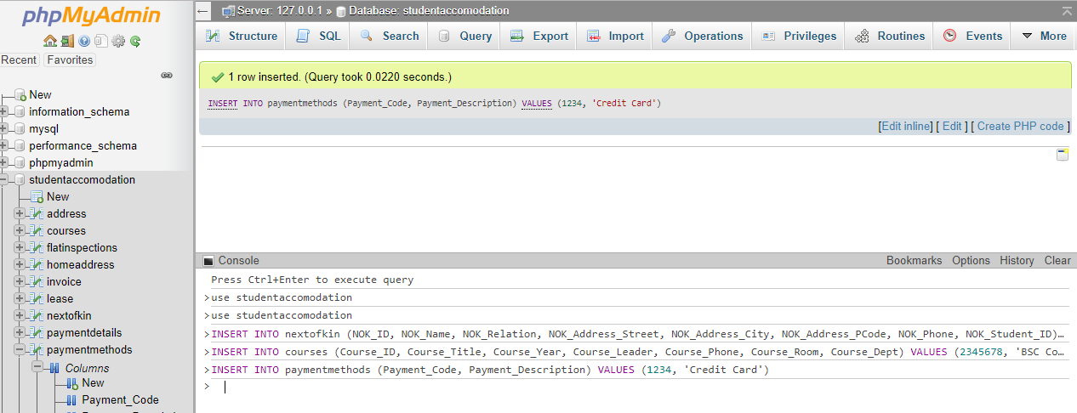

INSERT INTO paymentdetails

(Details_Code, Details_Payment_Code, Details_Student_ID, Details_Card_Number, Details_Card_Sort)

VALUES

(2345679, 1234, 1234567, '24356781', '201056');

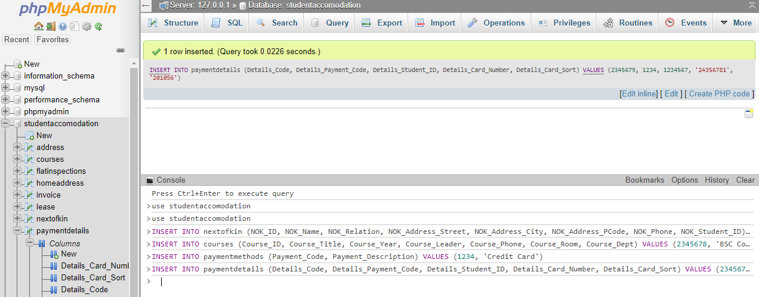

INSERT INTO invoice

(Invoice_Num, Invoice_Lease_Num, Invoice_Student_ID, Invoice_Place_Num, Invoice_Pay_Date, Invoice_Pay_Amount, Invoice_Payment_Code,

Invoice_First_Reminder, Invoice_Second_Reminder, Invoice_Sent_Date)

VALUES

(2163547, 4325679, 1234567, 1112201, 2018-10-02, 250.00, 1234, 2018-10-01, NULL, 2018-09-12);

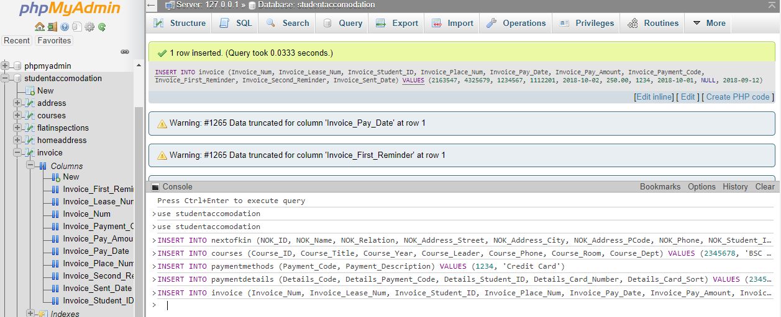

INSERT INTO studentaddress

(Stud_Address_ID, Stud_Lease_ID, Stud_Place_Num, Stud_Student_ID, Stud_Uni_Add_ID)

VALUES

(73664529, 4736253, 5326784, 1234567, 6342598);

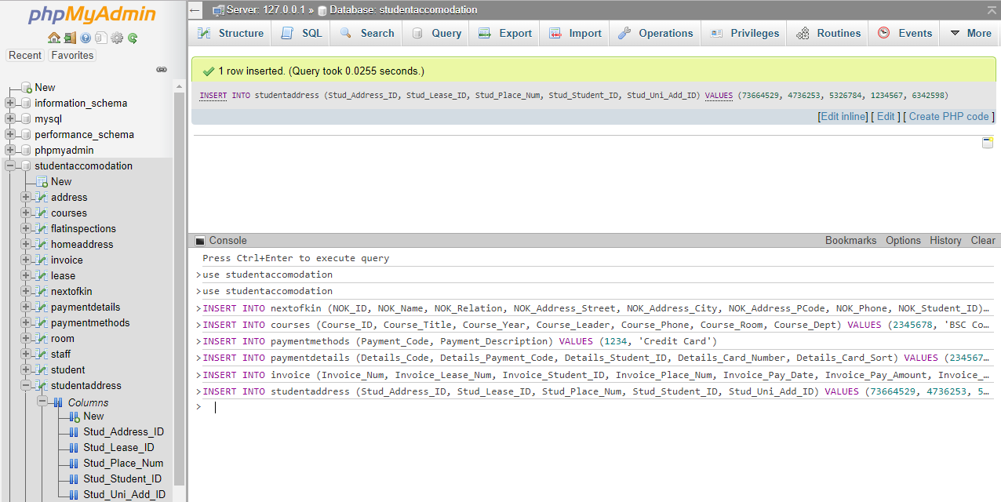

INSERT INTO lease

(Lease_Num, Lease_Duration, Lease_Rent_Rate, Lease_Start_Date, Lease_Finish_date, Lease_Student_ID, Lease_Student_Add_ID, Lease_Place_Num)

VALUES

(4736253, '3', 250.00, 20180902, 20190615, 1234567, 7364529, 5326784);

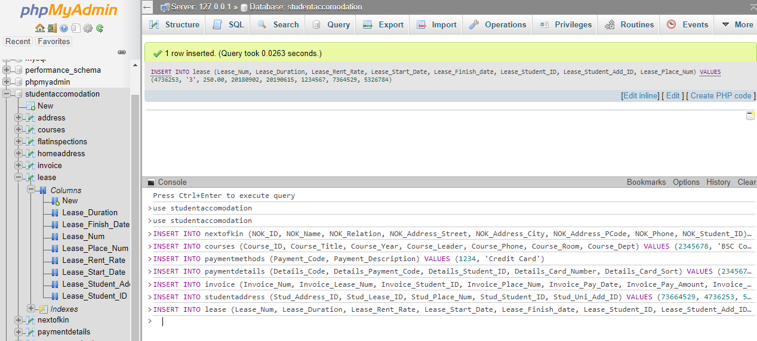

INSERT INTO flatinspections

(Inspect_ID, Inspect_Staff_ID, Inspect_Date, Inspect_Condition, Inspect_Comments, Inspect_Place_Num)

VALUES

(8263541, 6372518, 20180929, 'Satisfactory', NULL, 5326784);

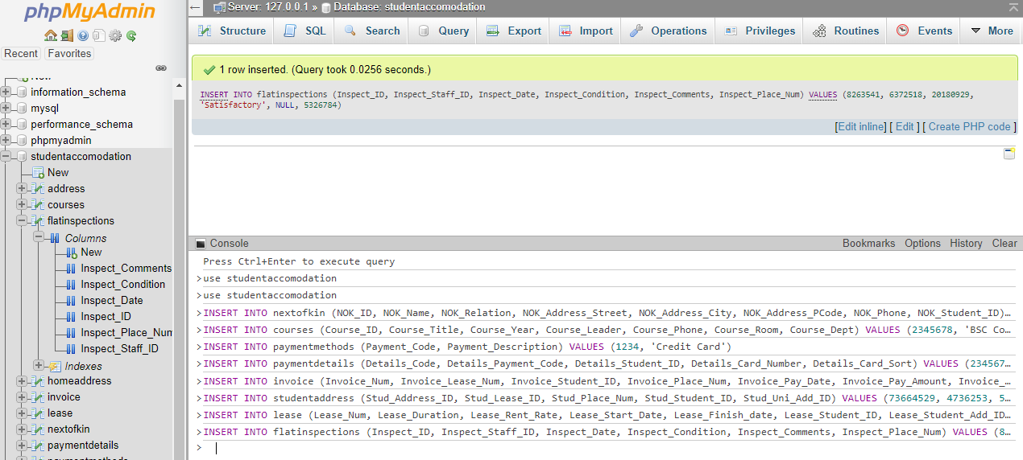

INSERT INTO staff

(Staff_ID, Staff_Name, Staff_Address_Street, Staff_Address_City, Staff_Address_Pcode, Staff_DOB, Staff_Position, Staff_Location_ID)

VALUES

(5372641, 'John Birmingham', '21 Street Lane', 'Bolton', 'BL5 1WE', 19770312, 'Manager', 8376354);

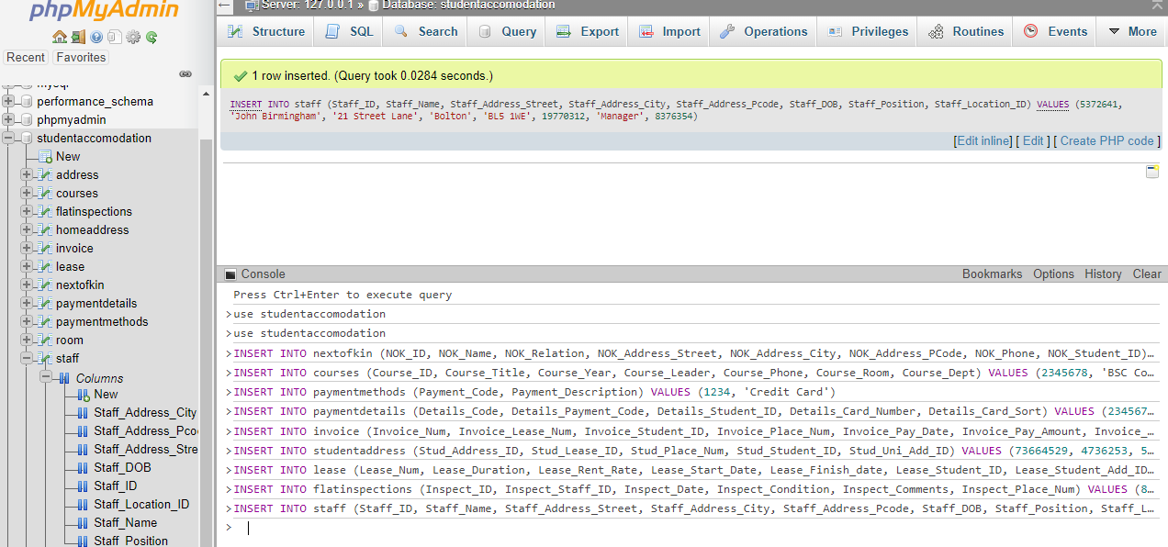

INSERT INTO uniaccomodation

(Uni_Accom_ID, Uni_Accom_Type, Uni_Accom_Building_Name, Uni_Accom_Num_Of_Rooms, Uni_Accom_Staff_ID, Uni_Accom_Add_ID)

VALUES

(6342598, 'Halls of Residence', 'Delta', 45, 5372641, 9263548);

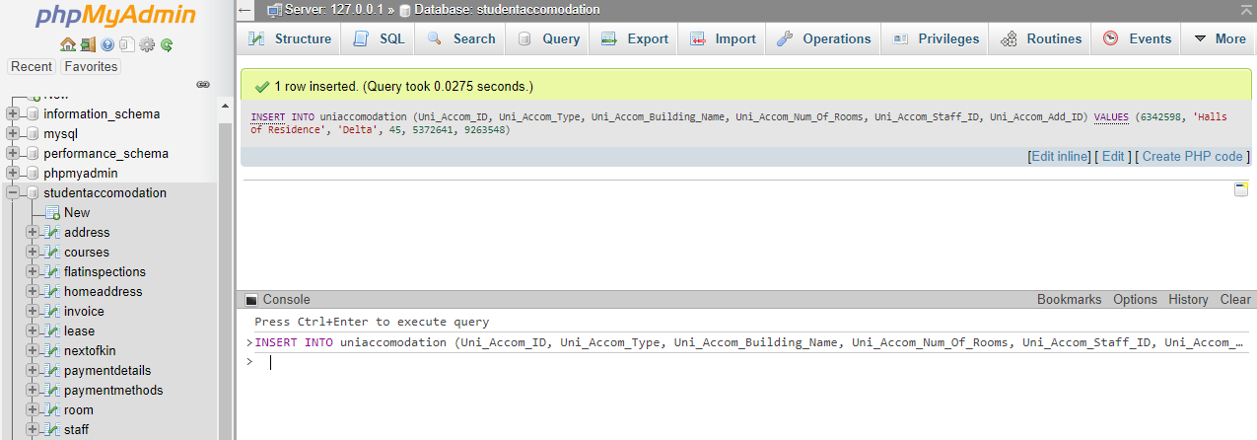

INSERT INTO address

(Add_ID, Add_Uni_Accom_ID, Add_Street, Add_City, Add_PCode)

VALUES

(9263548, 6342598, '123 Big Road', 'Bolton', 'BL4 5TH');

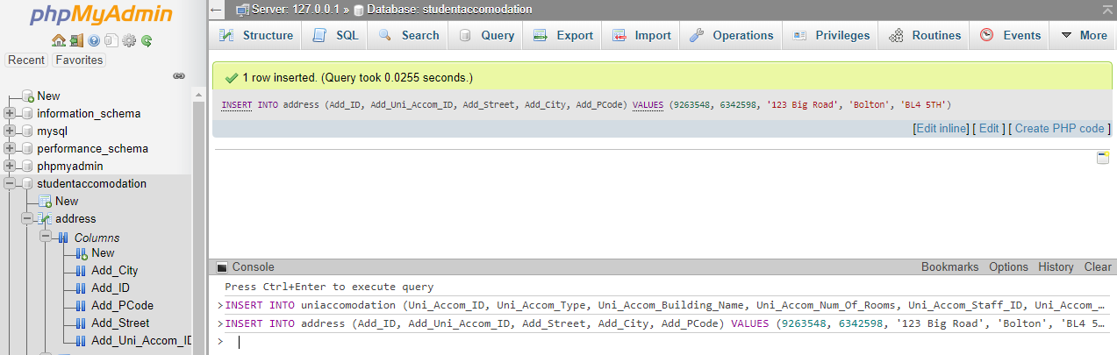

INSERT INTO room

(Place_Num, Room_Number, Room_Uni_Accom_ID)

VALUES

(5326784, '23', 6342598);

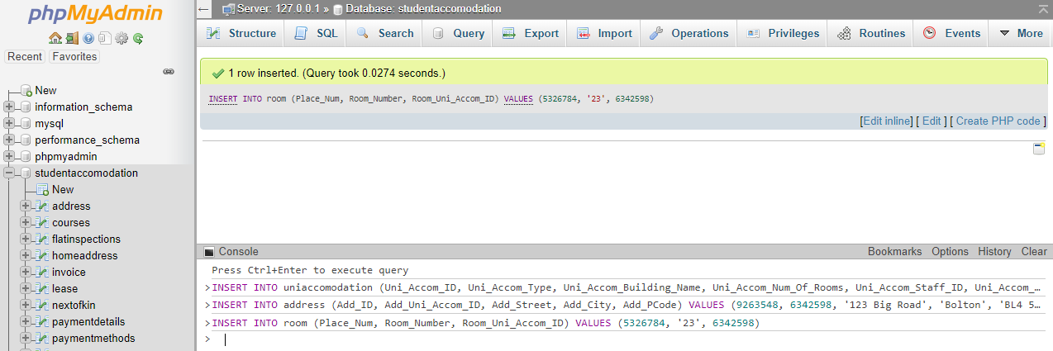

INSERT INTO student

(Student_ID, Student_First_Name, Student_Second_Name, Stud_Home_Add_ID, Student_NOK_ID, Student_Email, Student_Category, Student_Nationality,

Student_Smoker, Student_Special_Needs, Student_Comments, Student_Placed, Student_Course_ID, Student_Place_Num, Student_Date_Left_Uni)

VALUES

(1234567, 'Fred', 'Dingbat', 7365294, 2234567, 'fred@hotmail.com', '1st Year Under', 'British', 'Y', 'None', 'None', 'Y', 2345678, 5326784, NULL);

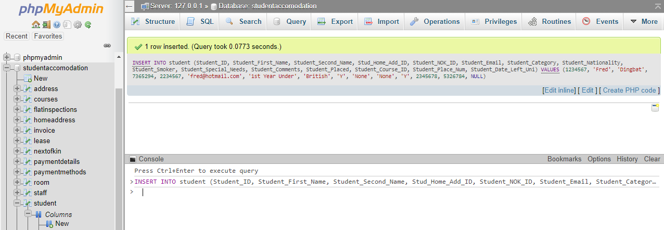

INSERT INTO homeaddress

(Home_Add_ID, Home_Add_Street, Home_Add_City, Home_Add_PCode, Home_Student_ID)

VALUES

(7365294, '42 Small Street', 'Bolton', 'BL3 5RT', 1234567);

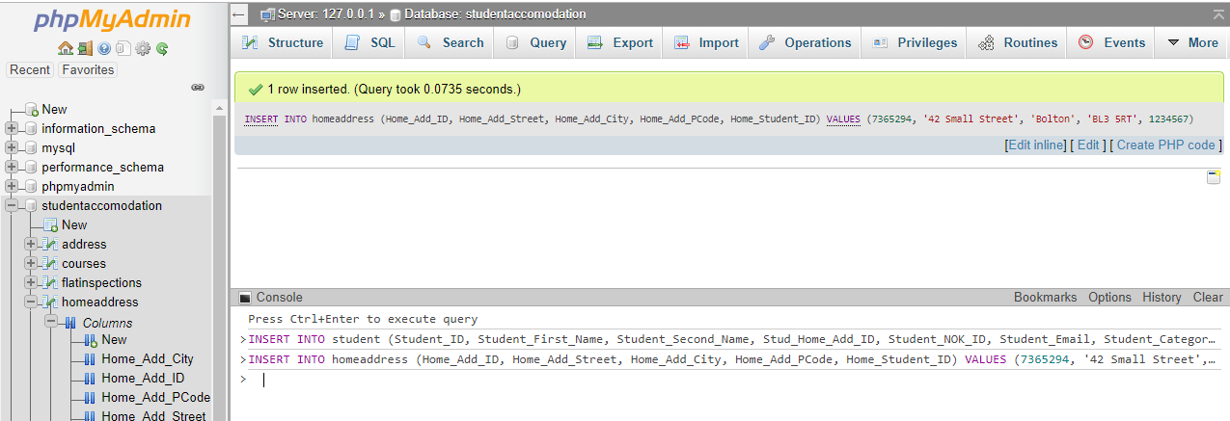

# CRUD Read

SELECT NOK_Name, NOK_Phone FROM nextofkin

WHERE

NOK_ID = 2234567

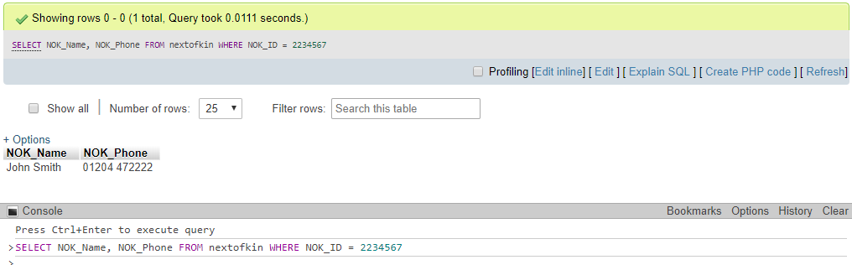

SELECT Course_Title, Course_Leader FROM courses

WHERE Course_ID = 2345678;

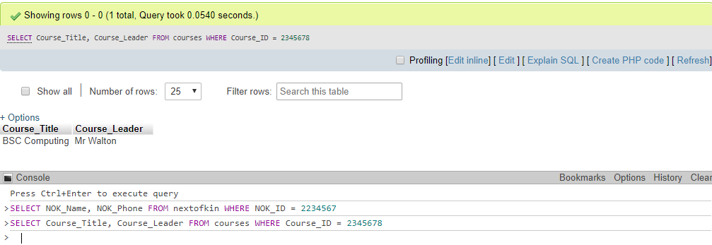

SELECT Payment_Code, Payment_Description FROM paymentmethods

WHERE

Payment_Code = 1234;

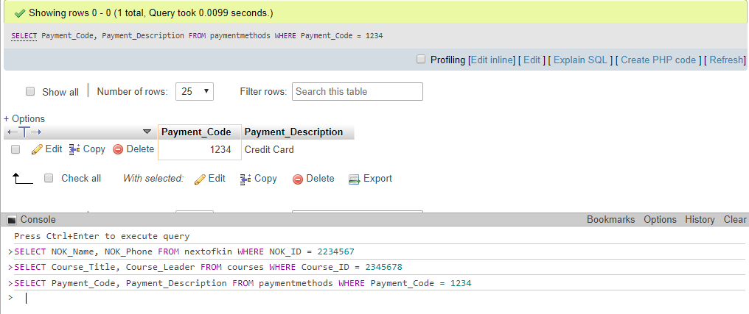

SELECT Invoice_Lease_Num, Invoice_Student_ID FROM invoice

WHERE

Invoice_ID = 2163547;

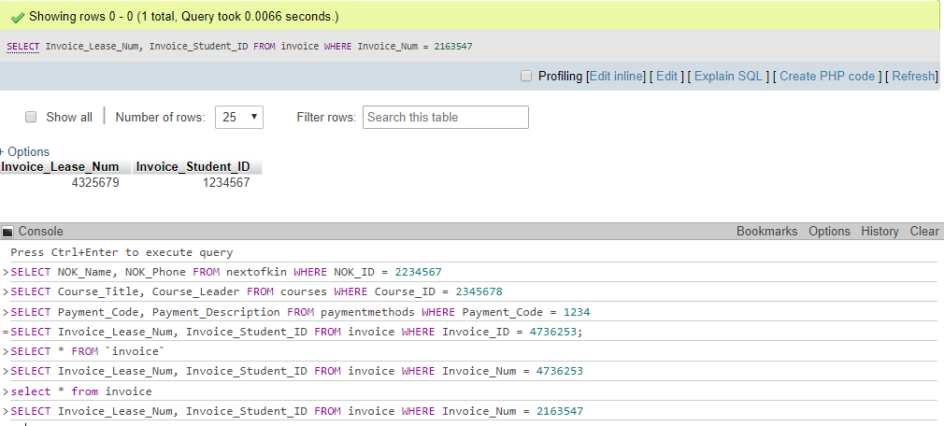

SELECT Stud_Place_Num, Stud_Uni_Add_ID FROM studentaddress

WHERE

Stud_Address_ID = 73664529;

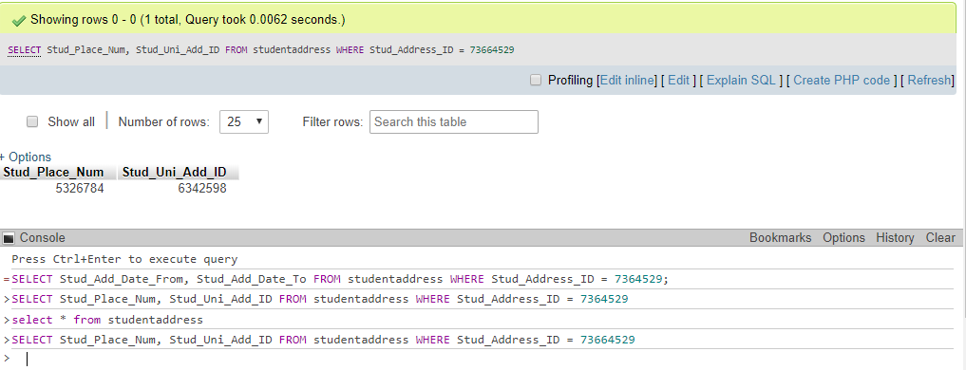

SELECT Lease_Duration, Lease_Rent_Rate FROM lease

WHERE

Lease_Num = 4736253;

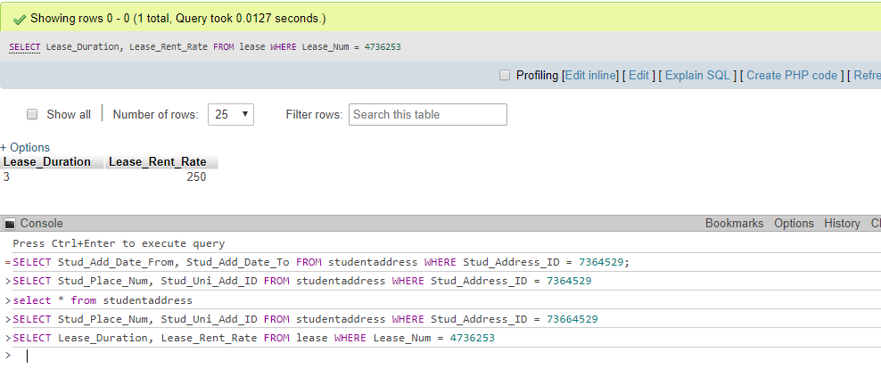

SELECT Inspect_Staff_ID, Inspect_Date FROM flatinspections

WHERE

Inspect_ID = 8263541;

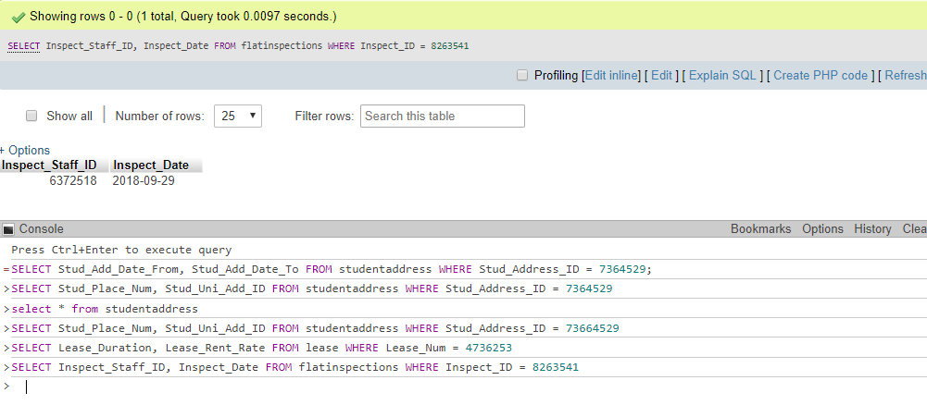

SELECT Staff_Name, Staff_DOB FROM staff

WHERE

Staff_ID = 5372641;

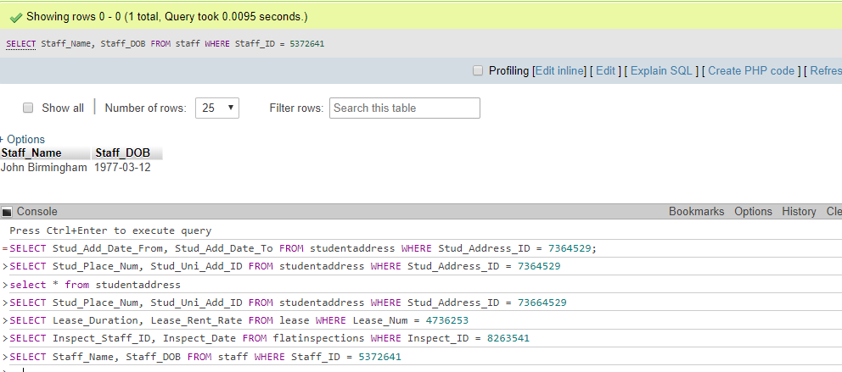

SELECT Uni_Accom_Building_Name, Uni_Accom_Staff_ID FROM uniaccomodation

WHERE

Uni_Accom_ID = 6342598;

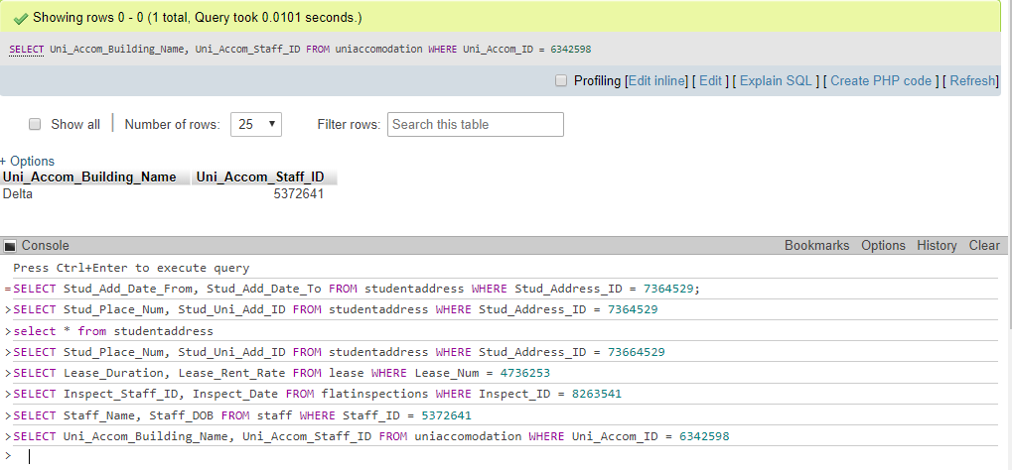

SELECT Add_Street, Add_City FROM address

WHERE

Add_ID = 9263548;

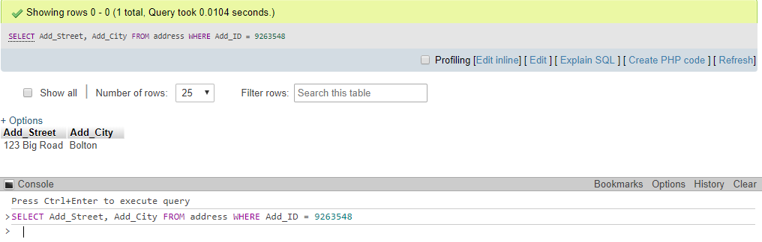

SELECT Room_Number FROM room

WHERE

Place_Num = 5326784;

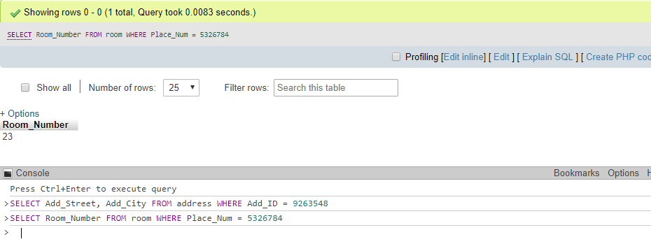

SELECT Student_Nationality, Student_Smoker FROM student

WHERE

Student_ID = 1234567;

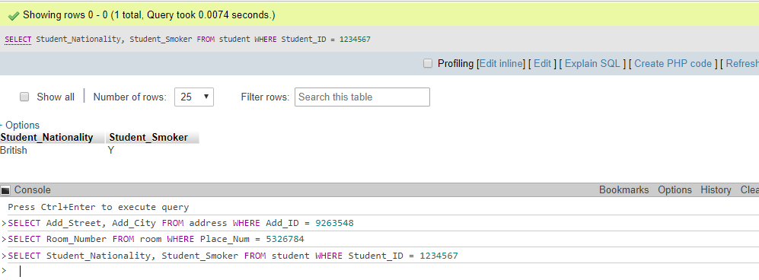

SELECT Home_Add_Street, Home_Add_PCode from homeaddress

WHERE

Home_Add_ID = 7365294;

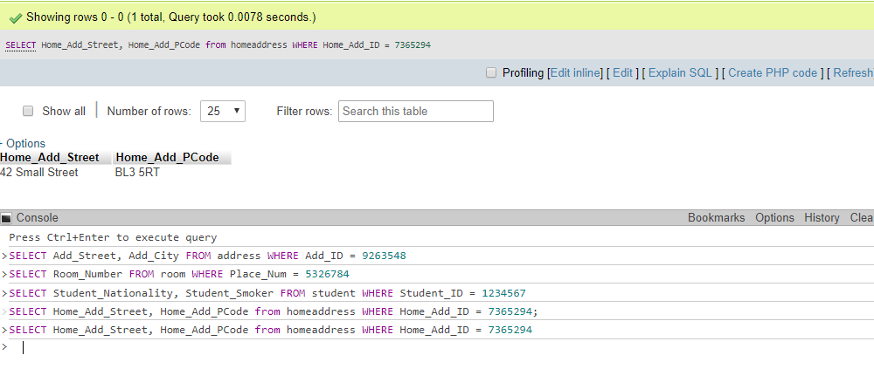

# CRUD Update

UPDATE NextOfKin

SET NOK_Name = 'Jane Smith'

WHERE NOK_ID = 2234567;

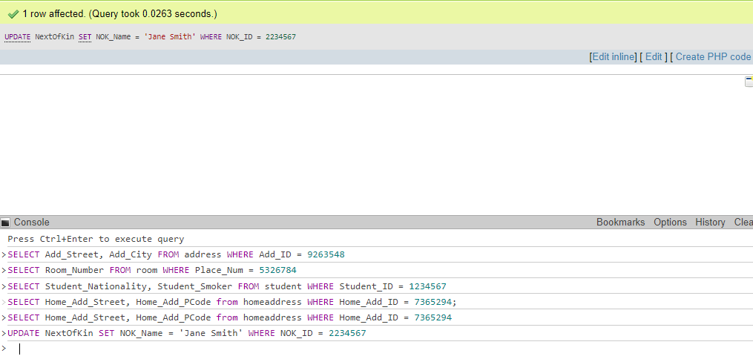

UPDATE Courses

SET Course_Title = 'BSC Computing with Gaming'

WHERE Course_ID = 2345678;

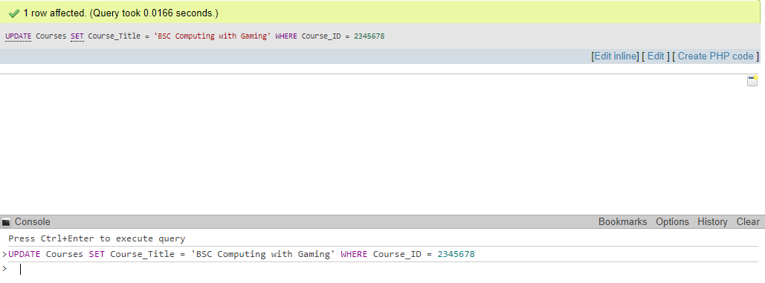

UPDATE PaymentMethods

SET Payment_Description = 'Debit Card'

WHERE Payment_Code = 1234;

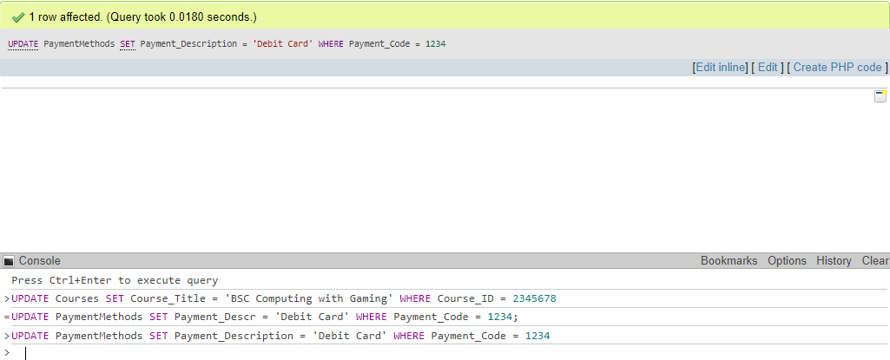

UPDATE PaymentDetails

SET Details_Card_Sort = 221056

WHERE Details_Code = 2345679;

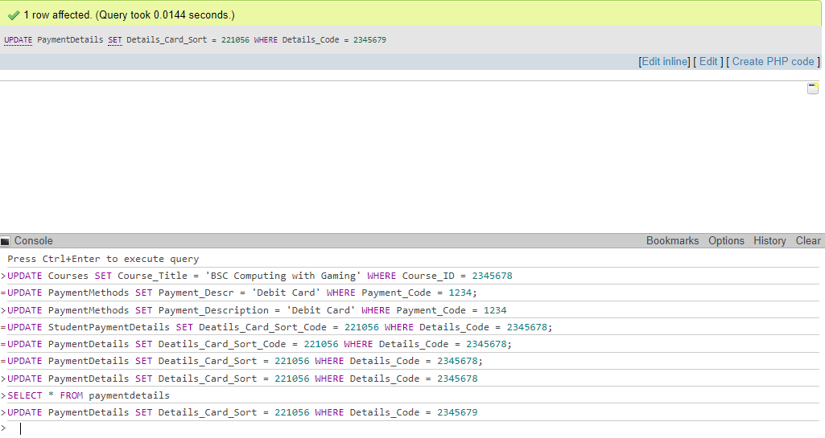

UPDATE Invoice

SET Invoice_Pay_Amount = 300

WHERE Invoice_Num = 2163547;

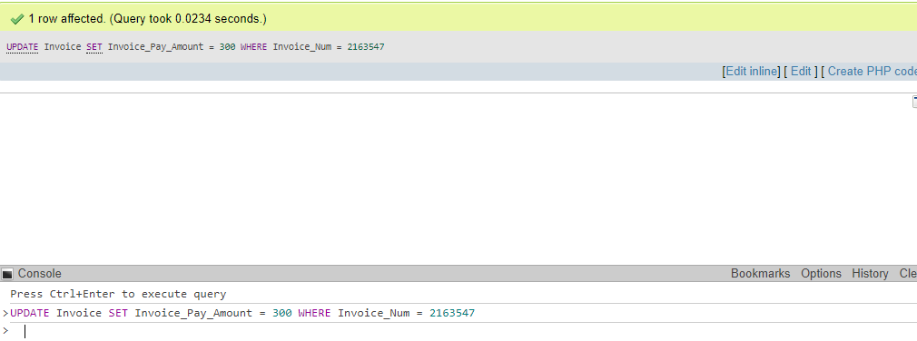

UPDATE StudentAddress

SET Stud_Uni_Add_ID = 9364528

WHERE Stud_Address_ID = 73664529

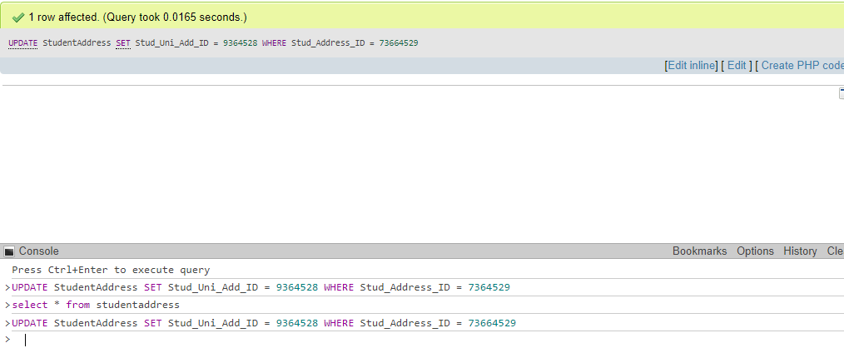

UPDATE Lease

SET Lease_Duration = '2', Lease_Rent_Rate = 750.00

WHERE Lease_Num = 4736253;

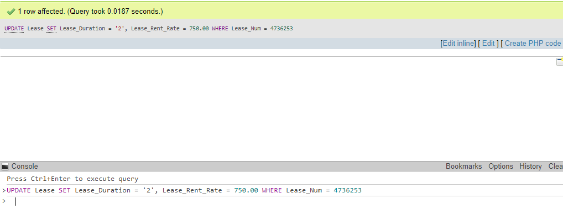

UPDATE FlatInspections

SET Inspect_Condition = 'Unsatisfactory'

WHERE Inspect_ID = 8263541;

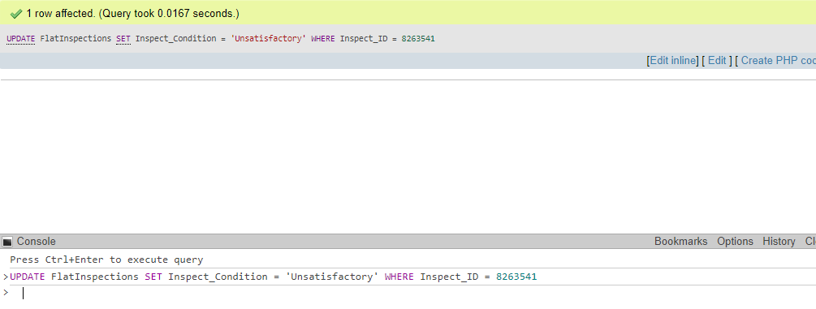

UPDATE Staff

SET Staff_Name = 'John Brighton'

WHERE Staff_ID = 5372641;

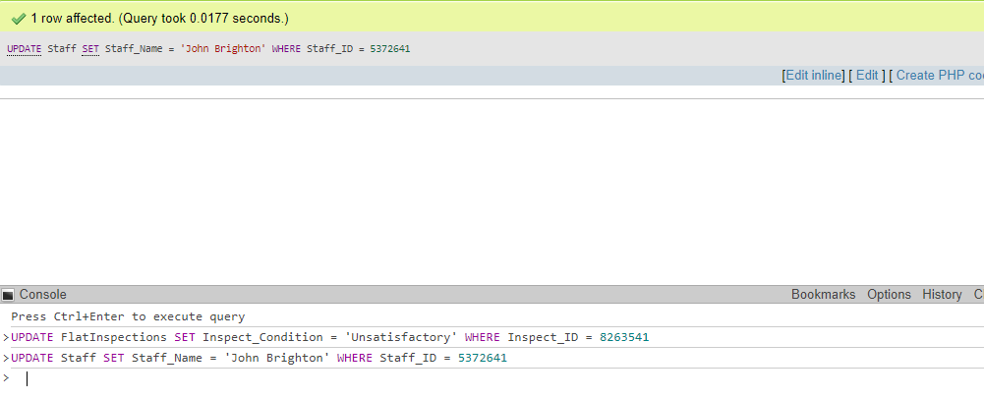

UPDATE UniAccomodation

SET Uni_Accom_Building_Name = 'Beta'

WHERE Uni_Accom_ID = 6342598;

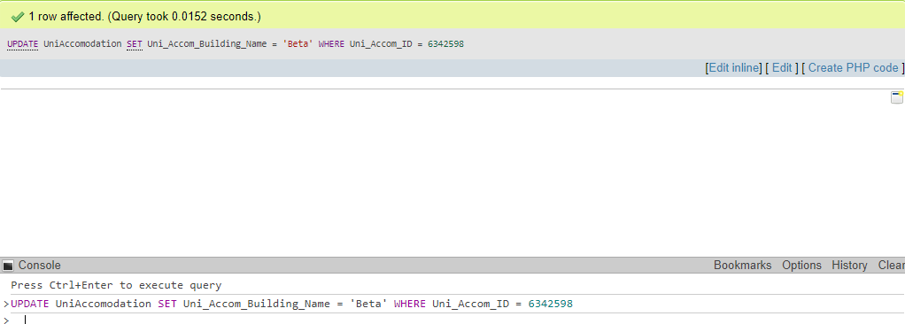

UPDATE Address

SET Add_Street = '98 Church Street'

WHERE Add_ID = 9263548;

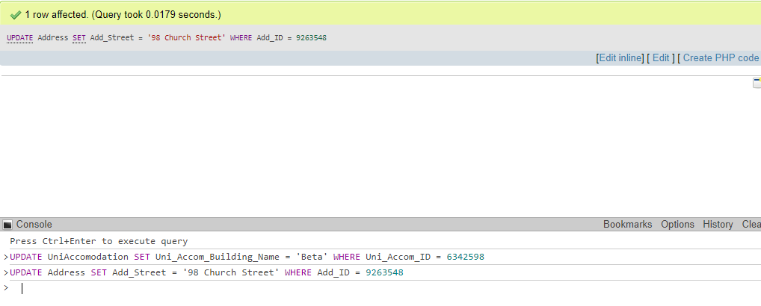

UPDATE Room

SET Room_Number = '22'

WHERE Place_Num = 5326784;

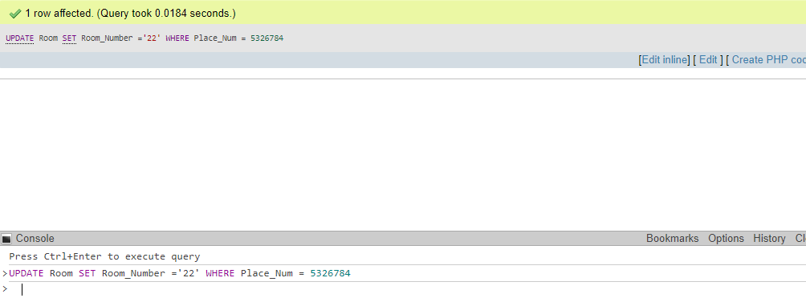

UPDATE Student

SET Student_First_Name = 'Frederick'

WHERE Student_ID = 1234567;

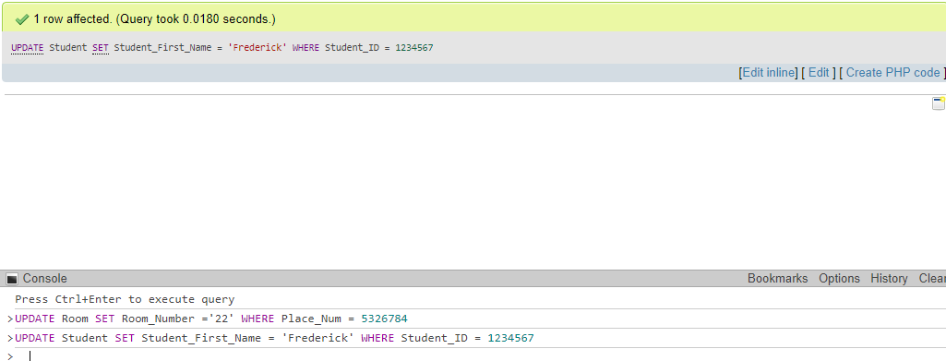

UPDATE HomeAddress

SET Home_Add_City = 'Leeds'

WHERE Home_Add_ID = 7365294;

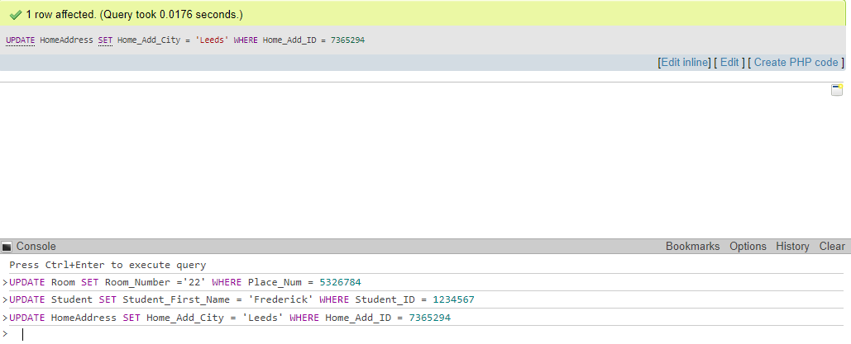

# CRUD Delete

DELETE FROM NextOfKin

WHERE NOK_ID = 2234567;

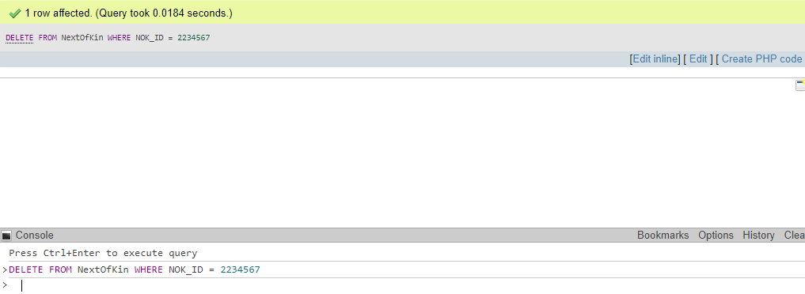

DELETE FROM Courses

WHERE Course_ID = 2345678;

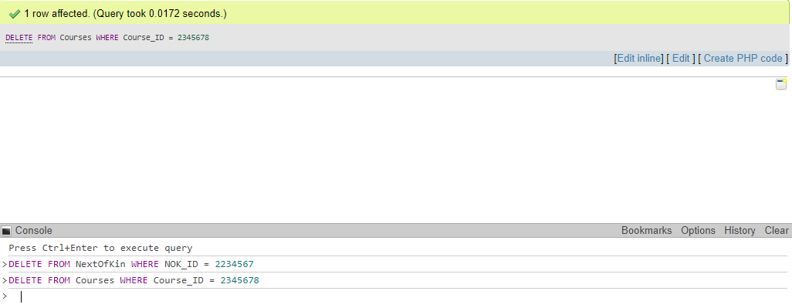

DELETE FROM PaymentMethods

WHERE Payment_Code = 1234;

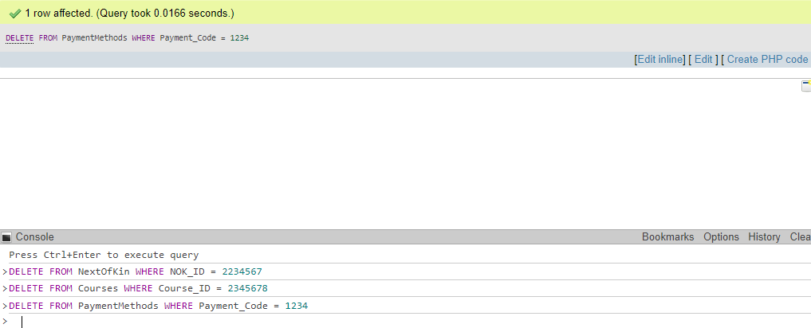

DELETE FROM StudentPaymentDetails

WHERE Details_Code = 2345679;

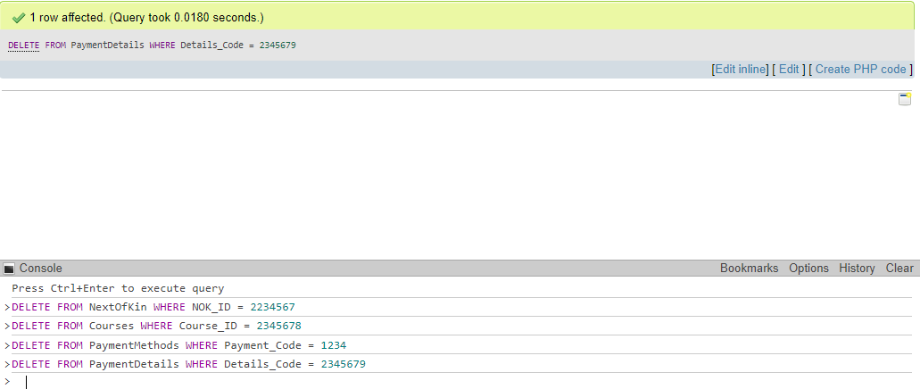

DELETE FROM Invoice

WHERE Invoice_Num = 2163547;

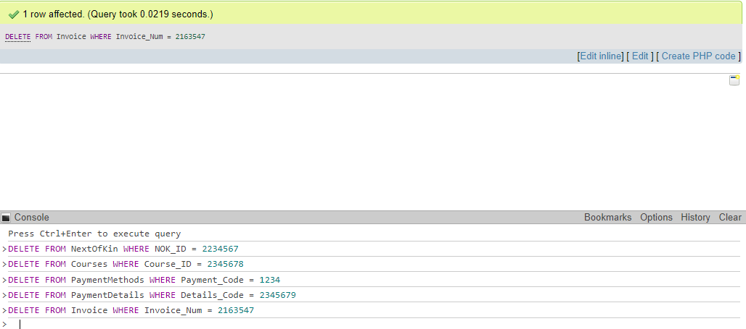

DELETE FROM StudentAddress

WHERE Stud_address_ID = 73664529;

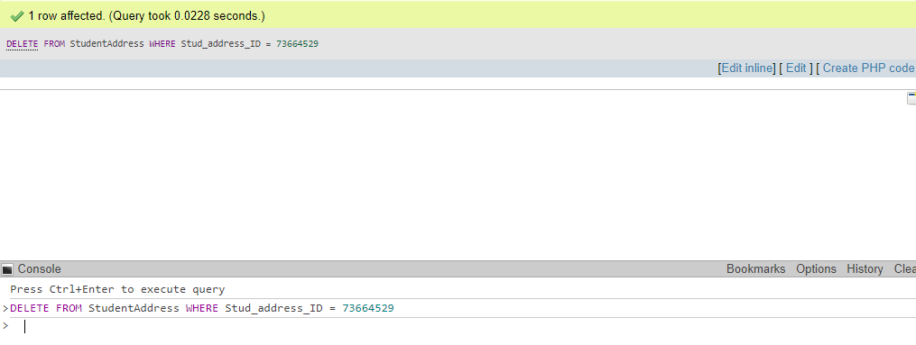

DELETE FROM Lease

WHERE Lease_Num = 4736253;

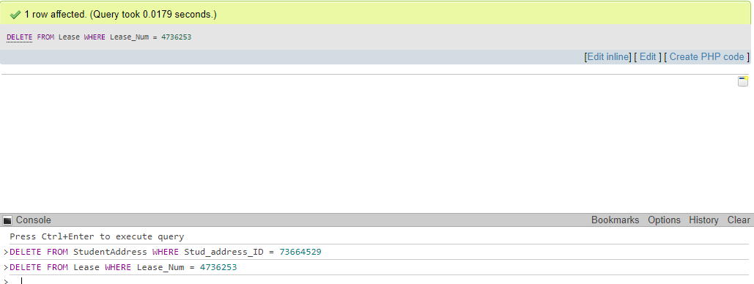

DELETE FROM FlatInspections

WHERE Inspect_ID = 8263541;

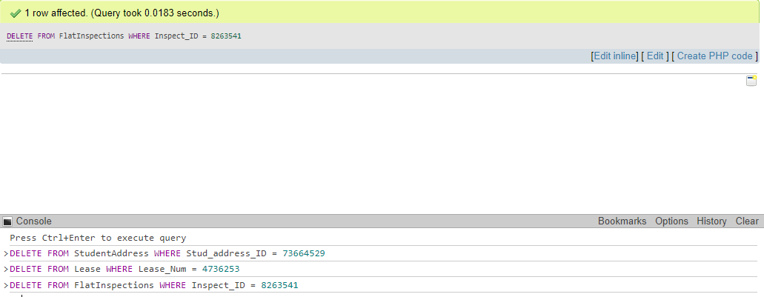

DELETE FROM Staff

WHERE Staff_ID = 5372641;

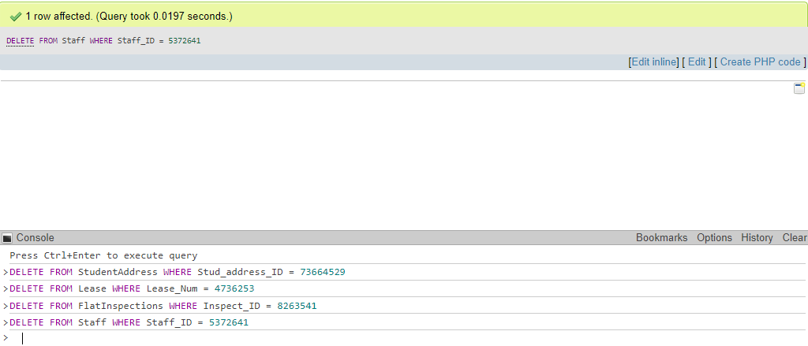

DELETE FROM UniAccomodation

WHERE Uni_Accom_ID = 6342598;

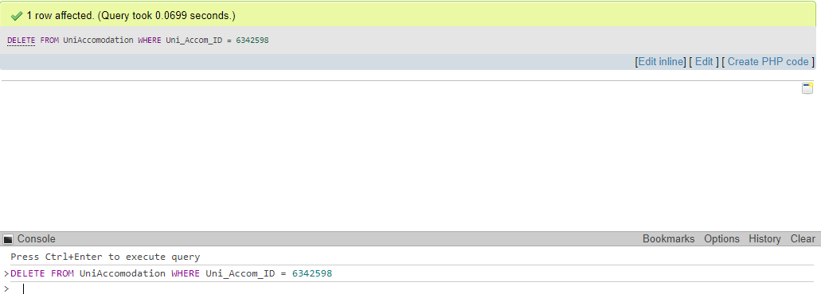

DELETE FROM Address

WHERE Add_ID = 9263548;

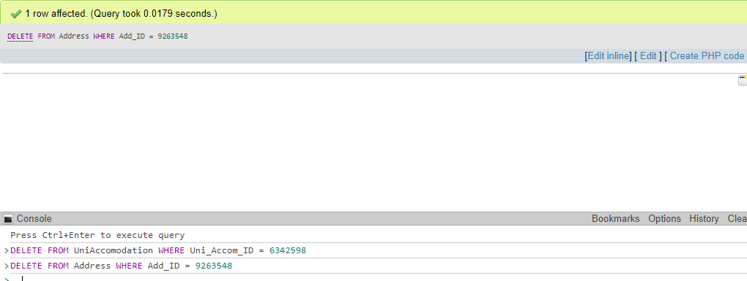

DELETE FROM Room

WHERE Place_Num = 5326784;

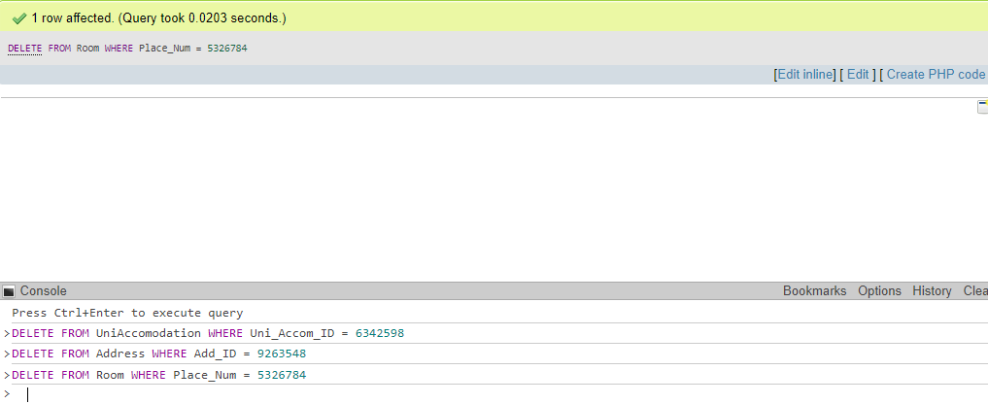

DELETE FROM Student

WHERE Student_ID = 1234567;

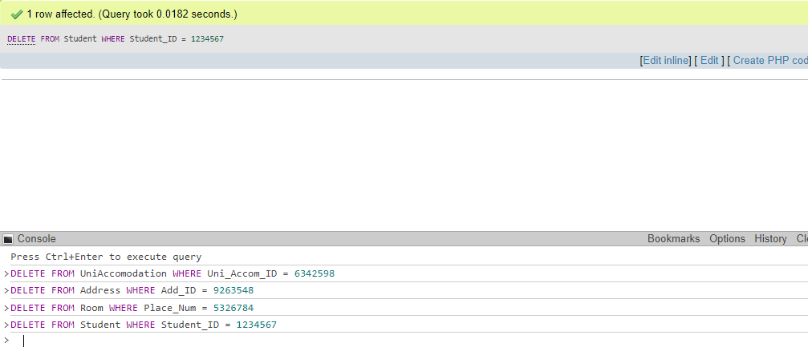

DELETE FROM HomeAddress

WHERE Home_Add_ID = 7365294;

